DATA DICTIONARY

ER DIAGRAM
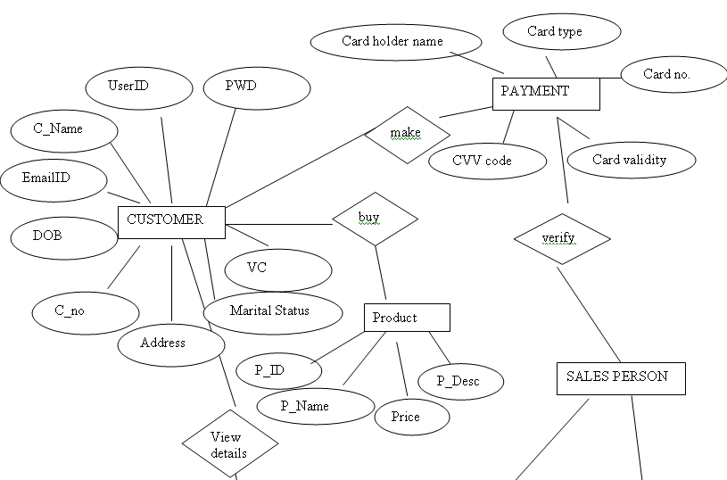
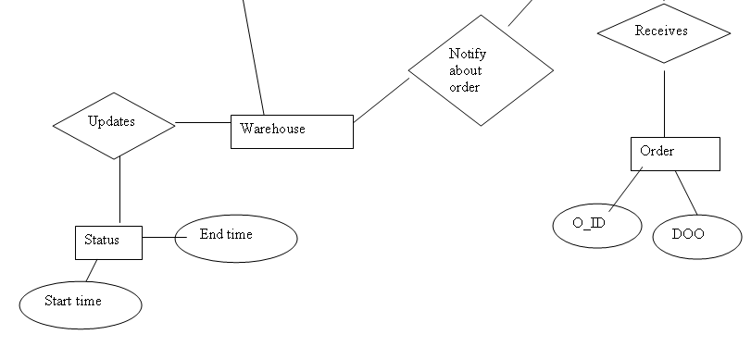

TABLE STRUCTURE

USERS TABLE

Column name | Data type | size | Allow nulls | Constraints | Remarks
Username | varchar | 50 | true | Foreign key
Password | varchar | 50 | true
Role | varchar | 50 | true

CUSTOMER TABLE

Column name | Data type | size | Allow nulls | Constraints | Remarks
Username | varchar | 50 | false | Primary key
Password | varchar | 50 | true
C_Name | varchar | 50 | true
DOB | datetime |  | true
Marital status | char | 10 | true
Contact no. | Int |  | true
Email_id | varchar | 50 | true
Postal address | Varchar | 50 | True
Verification code | varchar | 50 | True

PRODUCTS TABLE

Column name | Data type | size | Allow nulls | Constraints | Remarks
P_ID | varchar | 50 | False | Primary key
P_Name | varchar | 50 | True
price | decimal | (18,0) | True
P_Desc | Varchar | 50 | True

ORDER TABLE

Column name | Data type | size | Allow nulls | Constraints | Remarks
O_ID | varchar | 50 | False | Primary key
P_ID | varchar | 50 | true | Foreign key
P_Name | varchar | 50 | True
Price | decimal | (18,0) | True

PAYMENT TABLE

Column name | Data type | size | Allow nulls | Constraints | Remarks
Card Holder name | varchar | 50 | False | Primary key
C_Name | varchar | 50 | true | Foreign key
Card type | varchar | 50 | True
Card no. | decimal | (18,0) | True
Card Validity | datetime |  | True
Cvv code | varchar | 50 | True

ONLINE STATUS TABLE

Column name | Data type | Size | Allow nulls | Constraints | Remarks
User Name | varchar | 50 | true | Foreign key
P_ID | varchar | 50 | true | Foreign key
O_ID | varchar | 50 | true | Foreign key
Start time | datetime |  | true
End time | datetime |  | true

CLASS DIAGRAM
